MERN Stack development Lab
1) Create an application to set up the Node.js environment and display "Hello World"

Creating a Node.js "Hello World" Application
Objective:
To set up the Node.js environment and create a simple application that displays "Hello World" in the browser.

- Install Node.js
  - Download and install Node.js from the official website: https://nodejs.org
  - Verify installation using the commands:
  - node -v
  - npm -v
- Open Visual Studio Code
  - Launch VS Code and select a project folder located on the desktop (e.g., Desktop/first).
- Initialize Node.js Project
  - Open the integrated terminal in VS Code.
  - Run the following command to initialize the project:
npm init
  - Entere the required details (package name, version, description, entry point, etc.) to create package.json.
- Create Application File (index.js)
  - Create a new file named index.js in the project folder.
  - Write a basic Node.js server program to send "Hello World" as a response:
const http = require('node:http');

const hostname = '127.0.0.1';
const port = 3000;

const server = http.createServer((req, res) => {
res.statusCode = 200;
res.setHeader('Content-Type', 'text/plain');
res.end('Hello, World!\n');
});

server.listen(port, hostname, () => {
console.log(`Server running at http://${hostname}:${port}/`);
});

  - In the terminal, execute the application using:
node index.js

Output:
Server running at http://127.0.0.1:3000/
  - Opened a web browser and visited:
http://127.0.0.1:3000/
  - Confirmed that the message "Hello World" was displayed.

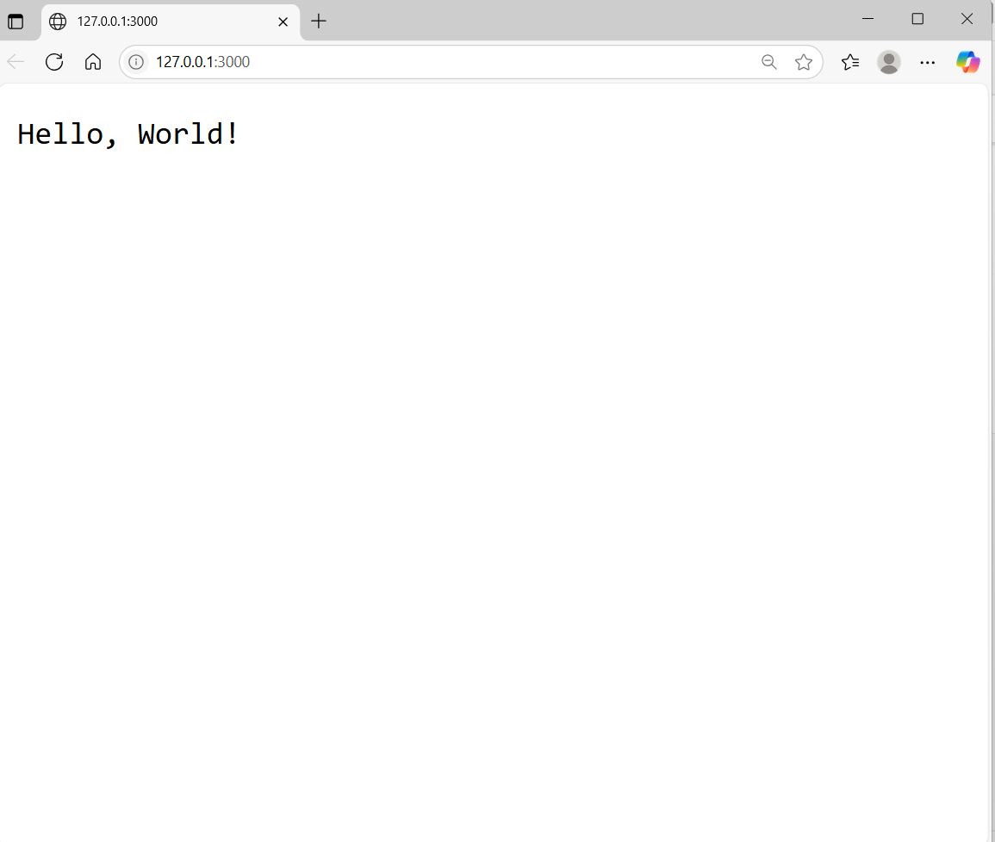

Understanding the code
const http = require('node:http');
const – This is a keyword used to declare a constant variable. It means the value of http cannot be changed later.
- Imports the built-in http module in Node.js, which is used to create an HTTP server.
const hostname = '127.0.0.1';
- Specifies the hostname (localhost) on which the server will run.
const port = 3000;
- Specifies the port number where the server will listen for incoming requests.
const server = http.createServer((req, res) => { ... });
- Creates the HTTP server.
- Takes a callback function with two parameters:
  - req: represents the request object.
  - res: represents the response object.
res.statusCode = 200;
- Sets the HTTP status code to 200, meaning the request was successful.
res.setHeader('Content-Type', 'text/plain');
- Sets the content type of the response to plain text.
res.end('Hello, World!\n');
- Ends the response and sends the text "Hello, World!" to the client.
server.listen(port, hostname, () => { ... });
- Starts the server and listens on the specified hostname and port.
- When the server starts successfully, it prints:
VIVA Questions
- Write the difference between let and const.
- What are Html Status codes.
- What does require('node:http') do?
- What is the use of createServer()?
- What are req and res in the callback function?
- What does res.statusCode = 200 mean?
- What is a port? Why do we use port 3000?
- Which command is used to run a Node.js program?

